**ANGULAR ARCHITECTURE**

Angular is a full-fledged model-view-controller (MVC) framework. It provides clear guidance on how the application should be structured and offers bi-directional data flow while providing real DOM.

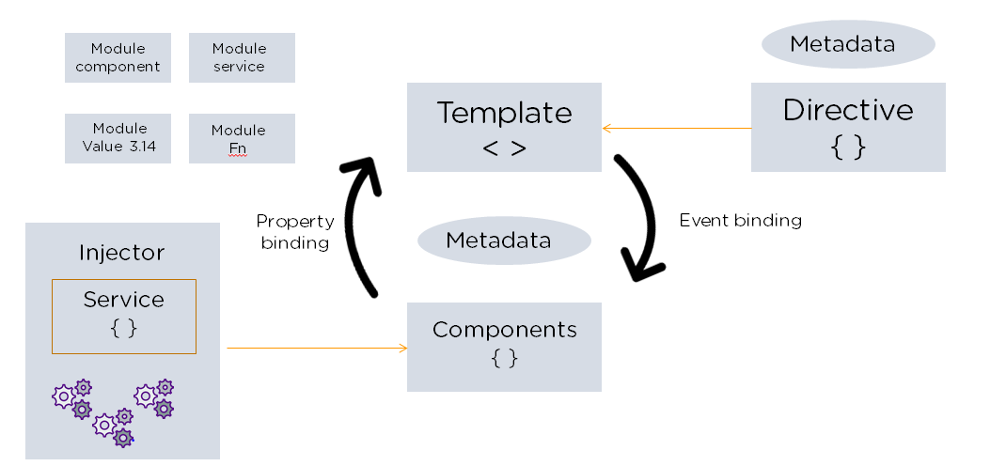

The following are the eight building blocks of an Angular application:

1. Modules

An Angular app has a root module, named AppModule, which provides the bootstrap mechanism to launch the application.

2. Components

Each [component](https://www.simplilearn.com/tutorials/angular-tutorial/angular-components) in the application defines a class that holds the application logic and data. A component generally defines a part of the user interface (UI).

## Advantages of Angular

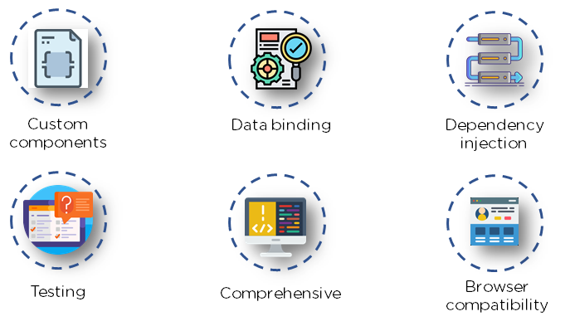

Many versions of Angular have been released since its inception. All these versions have added to the efficient working of the framework.

### 1. Custom Components

Angular enables users to build their own components that can pack functionality along with rendering logic into reusable pieces. It also plays well with web components.

### 2. Data Binding

Angular enables users to effortlessly move data from JavaScript code to the view, and react to user events without having to write any code manually.

### 3. Dependency Injection

Angular enables users to write modular services and inject them wherever they are needed. This improves the testability and reusability of the same services.

### 4. Testing

Tests are first-class tools, and Angular has been built from the ground up with testability in mind. You will have the ability to test every part of your application—which is highly recommended.

### 5. Comprehensive

Angular is a full-fledged framework and provides out-of-the-box solutions for server communication, routing within your application, and more.

### 6. Browser Compatibility

Angular is cross-platform and compatible with multiple browsers. An Angular application can typically run on all browsers (Eg: Chrome, Firefox) and OSes, such as Windows, macOS, and Linux.

## Limitations of Angular

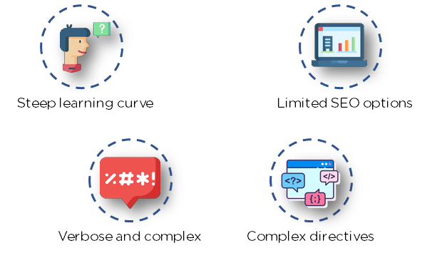

### 1. Steep Learning Curve

The basic components of Angular that all users should know include directives, modules, decorators, components, services, dependency injection, [pipes](https://www.simplilearn.com/tutorials/angular-tutorial/angular-pipes), and templates. More advanced topics include change detection, zones, AoT compilation, and Rx.js.

### 2. Limited SEO Options

Angular offers limited SEO options and poor accessibility to search engine crawlers.

### 3. Migration

One of the reasons why companies do not frequently use Angular is the difficulty in porting legacy js/jquery-based code to angular style architecture. Also, each new release can be troublesome to upgrade, and several of them are not backward-compatible.

### 4. Verbose and Complex

A common issue in the Angular community is the verbosity of the framework. It is also fairly complex compared to other front-end tools.

What Are the Differences Between Angular and AngularJS?

Angular is the catch-all term for every version of the framework (1-13), while AngularJS is the initial Angular version, renamed. Although it’s over ten years old, AngularJS isn’t obsolete; it still finds lots of use developing smaller web applications.

Here’s a handy chart outlining some of the basic differences.

|  |  |  |
| --- | --- | --- |
|  | **AngularJS** | **Angular** |
| **Architecture** | Supports mode-view component design | Uses directives and components |
| **Language** | JavaScript | Microsoft’s TypeScript |
| **Mobile capability** | No mobile browser support | Supported by all popular mobile browsers |
| **Structure** | Not as manageable as Angular, but ideal for small applications | Easier to build and maintain large applications |
| **Routing** | Uses $routeprovider.when() for routing configuration | Uses @Route Config{(…)} for routing configuration |
| **Performance** | Not as fast as Angular | Faster than AngularJS |

Companies Using Angular

Many top tier companies, such as Google, Nike, Upwork, HBO, and others leverage Angular.

